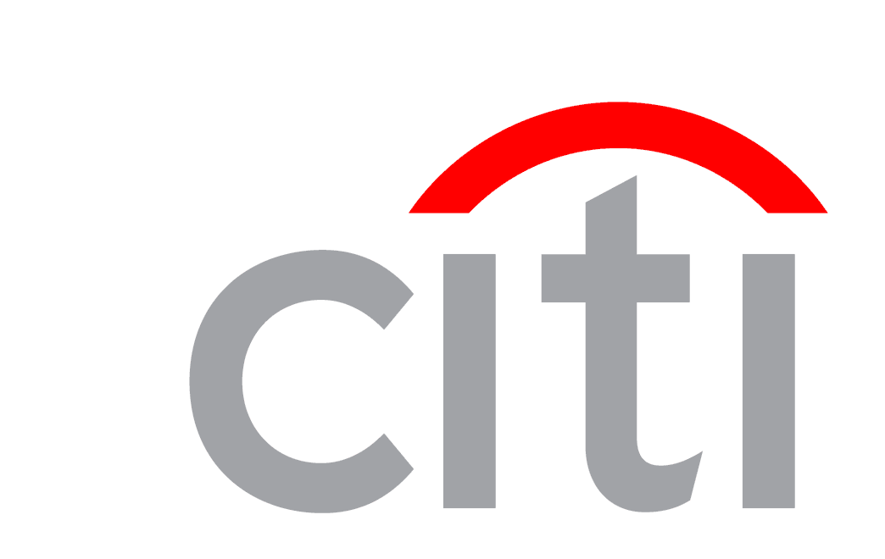

Institutional Clients Group Technology
Architecture Process
Architecture Definition

CCMS

© 2011, Citi, Inc.
All rights reserved. These materials are for Internal Use only and proprietary to Citi, Inc. No part of these materials must be reproduced or published in any form by any means electronic or mechanical (including photocopy or any information storage or retrieval system), nor must these materials be disclosed to third parties without the express written authorization of Citi, Inc.
Document Control
- Document History
The following table tracks information regarding new and revised versions of this document and briefly describes the changes made.
Version | Date | Compiled by | Description
1.0 | 18-09-12 | Aminul Bari | Draft
1.1 | 13-11-12 | Aminul Bari | Revised

- Document Approvals/Key Contacts

Title | Name | Phone # | Key Contact | Reviewer | Approver

TABLE OF CONTENTS
1. Introduction 1
1.1 Scope 1
1.2 Business Goals & Objectives 1
1.3 Domain Alignment 1
1.3.1 Consolidation and Retirement 1
1.4 Functional Requirements 1
1.5 Assumptions 1
2 Technical Approach 2
2.1 Logical Architecture 3
2.2 Physical Architecture 4
2.2.1 Network Configuration 4
2.2.2 Servers 4
2.2.3 Storage 4
2.2.4 Technology Stack 4
2.2.5 EOVS Products 5
2.2.6 Third-party Libraries 5
2.3 Data Interface 5
2.4 Information Architecture 7
3 User Interface 7
4 Information Security 8
5 Non-functional Requirements 8
5.1 Availability 8
5.2 Scalability and Estimated Volume Growth 8
5.3 Archival and Retention 8
5.4 Audit and Logging 8
5.5 Regulatory and Risk Considerations 8
5.6 Testing 8
5.7 Performance and Service Level Agreements 8
5.8 Monitoring 8
5.9 Access to Production 9
5.10 Support 9
6 Deployment 9
7 Data Standards (Mandatory) 9
7.1 Currency Code 9
7.1.1 Applicability 9
7.1.2 Adoption: 9
7.2 Standard Account 10
7.2.1 Applicability 10
7.2.2 Adoption: 10

Introduction
The software is designed to keep tracks of all collection information such as client deposit at different location, generate reminder, maintain billing, DD information and generate handoff file for FlexCube..

Scope
Scope of this document is the high level architecture of the application.

Business Goals & Objectives
- Maintain clearing check details
- Generates booking, reversal, return files for other system
- Upload DD information from CCMS
- Maintain both same Day clearing and normal clearing
- Generates various reports for MIS.

Domain Alignment
Collection, Cash Operations

Consolidation and Retirement
No other systems is consolidated or retired for this system

Functional Requirements
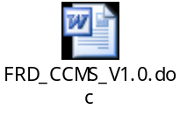

Assumptions
No assumption

Technical Approach
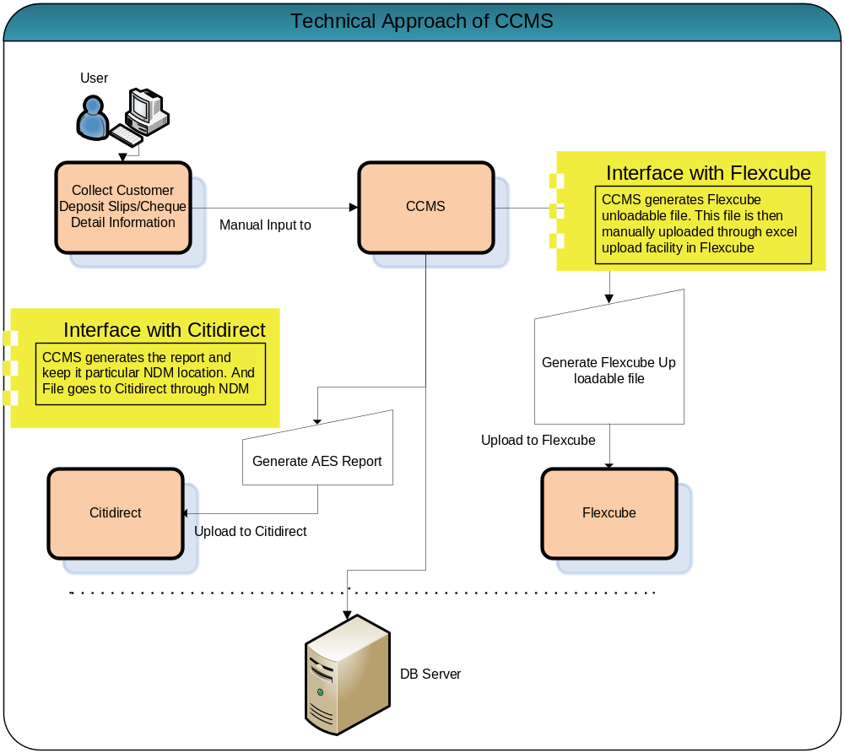

Logical Architecture

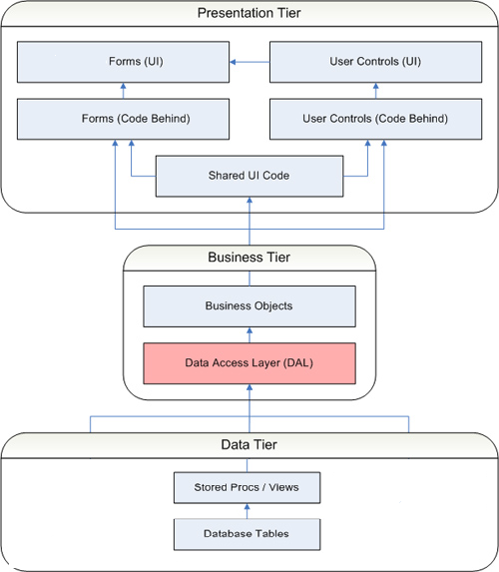

Physical Architecture

Network Configuration
Server will be placed in citi GRN

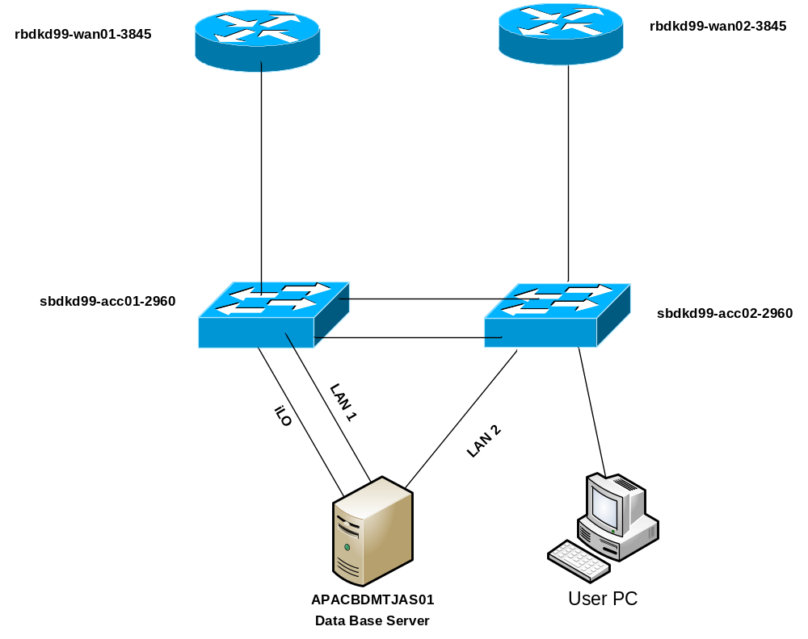

Servers
DB server will be required.
DB Server Configuration:APACBDMTJAS01
- OS: Windows Server 2003 Standard Edition
- SQL Server 2005

Storage
Primary storage is DB Server.

Technology Stack
SQL server
Microsoft .Net Framework

Global Version  Classification |  | Version  ID |  | Version |  |  |  | Description
  Platform
 | 56656 |  | SQL Server 2008 R2 Standard Edition 32-bit SP2 |  |  |  | Microsoft SQL Server 2008 R2 is the latest release of SQL Server it extends the performance, reliability, availability and programmability of SQL Server 2000/2005. SQL Server 2008 R2 includes new features that make it an excellent database platform for large-scale online transactional processing, data warehousing, and e-commerce applications. |  | Windows Server
  CUR
 |  | 115 |  |  | Microsoft .NET Framework Runtime | This product is the .NET framework redistributable [runtime]: there is a separate product entry for the .NET Framework SDK. .NET Framework is a new computing platform that simplifies application development in the highly distributed environment of the Internet. The .NET Framework has two main components: the common language runtime and the .NET Framework class library. Includes [framework 1.0][framework 1.1][framework 2.0] [framework 2.0 sp1][framework 2.0 sp2][framework 3.0][framework 3.0 sp1][framework 3.5][framework 3.5 sp1] |  |  |  | Windows
  RECOMMENDED

EOVS Products
None

Third-party Libraries
No third party libraries have been used.

Data Interface

Application | Interface with | Interface Mechanism | Classification | PII
CCMS | Flexcube | Manual Excell Upload | Confidential | No
CCMS | Citidirect | NDM | Confidential | Yes

Data Flow Diagram
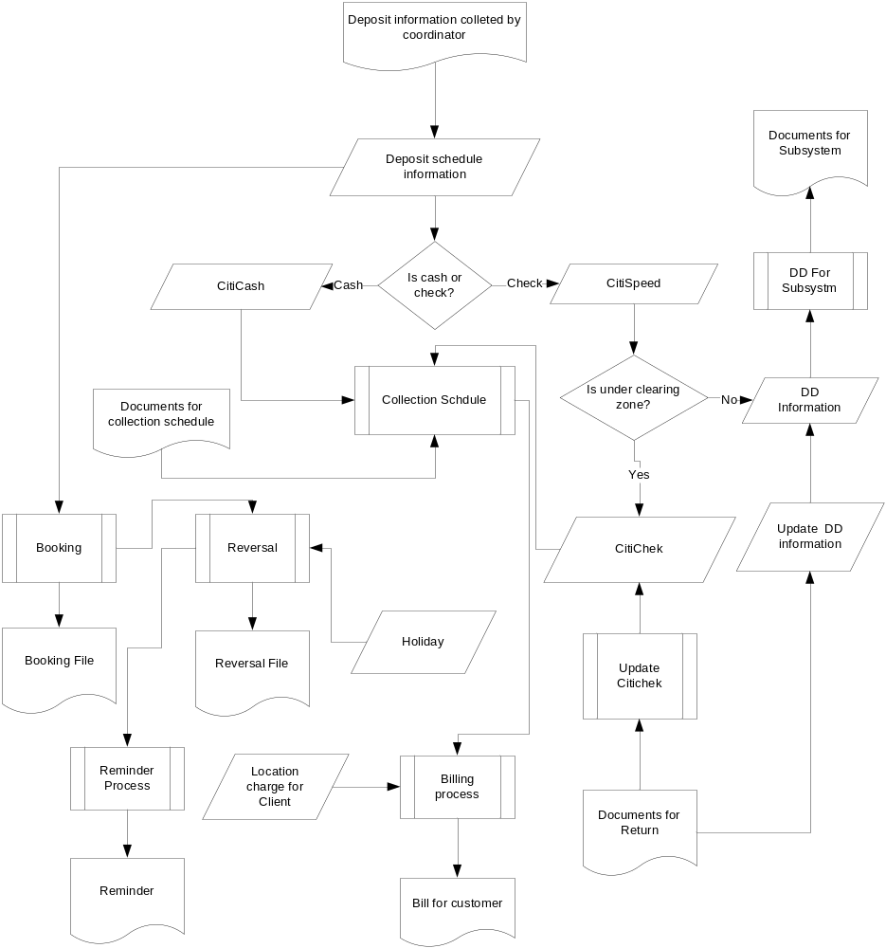

Information Architecture

User Interface
Standard graphical user interface has been used. Following is an example of user interface…

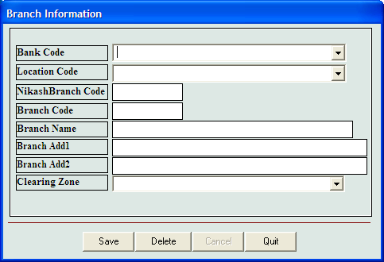
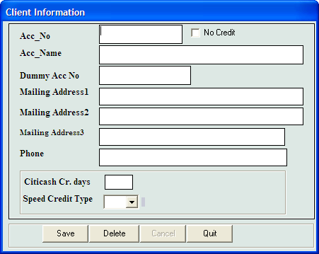

Information Security
There are 2 types of Users. These are

- Administrator – It creates user of General Type
- General User – This type of user perform operation to the System.

Non-functional Requirements

Availability
System will be available all the time with the following green zone.
Green zone on Working Day:
Day: Sunday to Thursday
Time: 9:00 pm to 9:00am BST

Green Zone on NoN-Working Day:
Friday:
Time: 10:00am to 10:00pm
Saturday:
Time: 4:00am to 10pm

Scalability and Estimated Volume Growth
1600 transaction per day. Extimated growth 400.

Archival and Retention
Database / App server will be backed up each day and then copied to tape as per CTI procedure.

Audit and Logging
There will be audit logging for user creation and transactions

Regulatory and Risk Considerations
Data will be confidential however it is not PII (Personally Identifiable Information).

Testing
Testing is performed in UAT server

Performance and Service Level Agreements

Monitoring
Human monitor. If any problem arises then vendor support will be taken

Access to Production
According to the Role description.

Support
Vendor support will be available according to SLA

Deployment
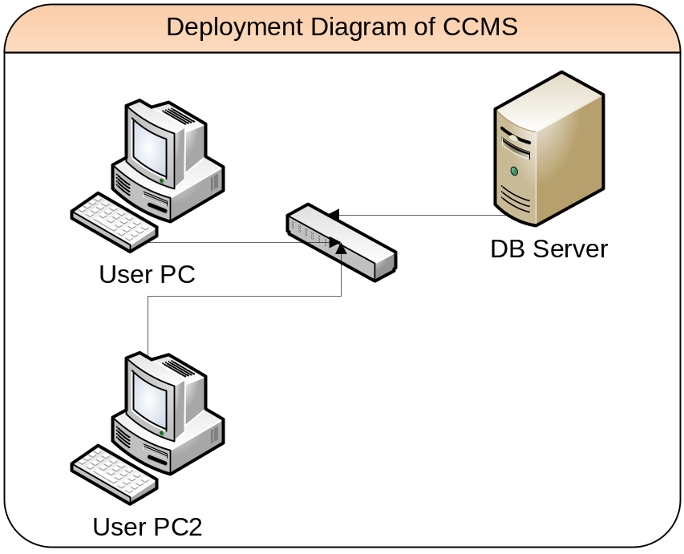

Application needs to be installed on users pc.

Data Standards (Mandatory)

Currency Code

Applicability
Yes

Adoption:
Adopted

Standard Account

Applicability
Yes

Adoption:
Adopted

